World Bank Project Report
Exploring the Relationship Between Internet Usage, Education, and Economic Growth in Africa (2000–2024)

Executive Summary
This project examined whether internet penetration and secondary school enrollment correlate with GDP growth across African nations over a 24-year period. Using a cleaned dataset of 1,109 observations, I applied exploratory data analysis, correlation matrices, and multiple linear regression to test these relationships.
The results are clear: secondary education is a robust, positive predictor of economic growth, while internet usage, despite its statistical significance, shows a weak negative association with GDP growth in this context. Our regression model explains roughly 37% of the variation in economic output, suggesting that education, rather than connectivity alone, remains the more substantial lever for development across the continent.

1. Introduction & Data Overview
Economic growth across Africa is shaped by a complex mix of infrastructure, policy, and human capital. This study sets out to answer a specific question: To what extent do internet usage and secondary school enrollment explain variations in GDP growth?
To investigate, I used a panel dataset containing 1,134 records spanning 2000 to 2024, covering multiple countries with variables for GDP growth, internet usage, and secondary enrollment. Initial data quality checks revealed only 25 missing values (2.2%) in the enrollment metric; after listwise deletion, our final analytical sample stood at 1,109 complete cases.

2. Descriptive Trends
The data reveals considerable heterogeneity across the region:
- GDP Growth averaged 16.54%, but with a median of just 7.24% and a standard deviation of 20.57, highlighting a positively skewed distribution driven by a few high-growth outliers.
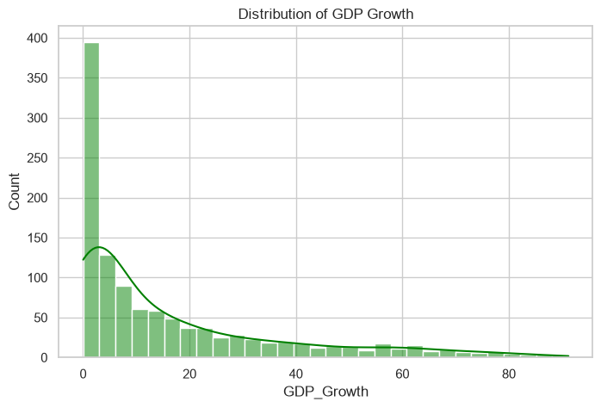
- Internet Usage showed a mean of 3.96% yet ranged from a suspicious minimum of -50.34% to a maximum of 86.83%. These extreme negative values likely point to reporting anomalies rather than actual disconnections, signaling a need for cautious interpretation.
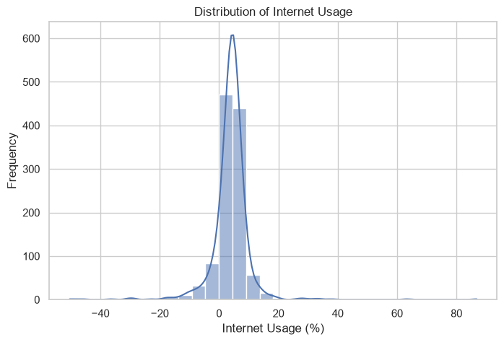
- Secondary Enrollment averaged 47.35%, with some countries exceeding 100%a plausible outcome given that gross enrollment ratios include students outside the official age bracket. Top performers like Libya, Algeria, and South Africa consistently led in this area, while Seychelles, Morocco, and Mauritius topped the list for average GDP growth.
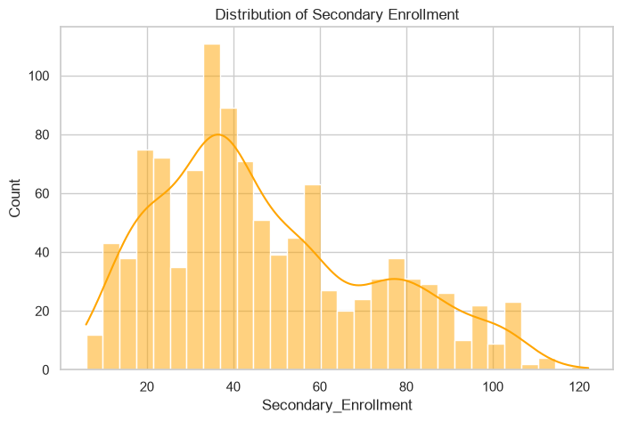

3. Correlation and Regression Analysis
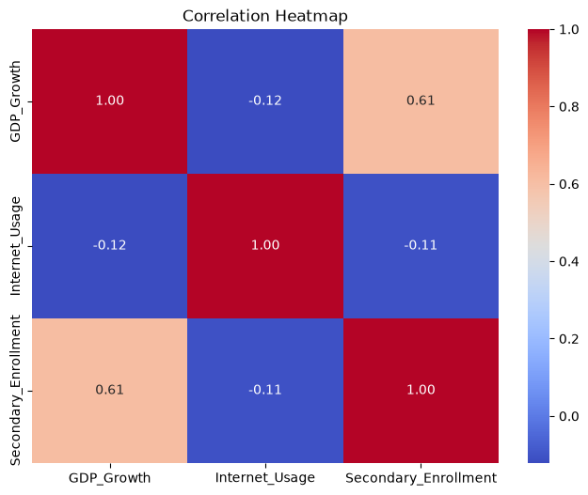
Pearson correlation offered an initial glimpse into the dynamics at play. The strongest relationship by far was between GDP growth and secondary enrollment (r = 0.607). In contrast, internet usage showed negligible correlations with both GDP growth (r = -0.122) and enrollment (r = -0.107).
To dig deeper, I constructed a multiple linear regression model:
GDP Growth = β₀ + β₁ (Internet Usage) + β₂ (Secondary Enrollment)
The model produced an R² of 0.372 (Adjusted R² = 0.31) with a highly significant F-statistic (p < 0.001). The coefficients tell a compelling story:
- Secondary Enrollment (β = 0.490, p < 0.001): Holding internet usage constant, a one-percentage-point rise in enrollment is linked to a 0.49-point increase in GDP growth. This was, by far, the most influential factor in our model.
- Internet Usage (β = -0.179, p = 0.017): Surprisingly, the coefficient was negative and weakly significant. Rather than suggesting that internet access hampers growth, this likely reflects omitted variable bias, structural economic differences, or data quality issues, underscoring that correlation is not causation.

4. Model Diagnostics and Limitations
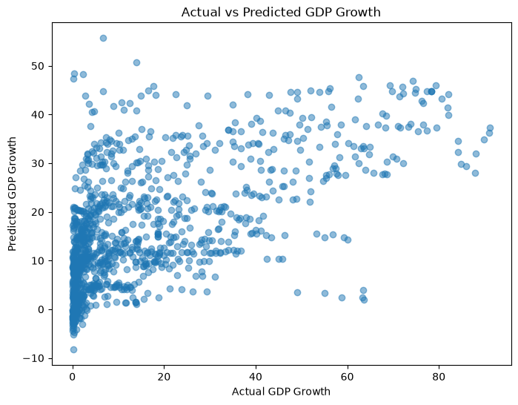
When I plotted actual versus predicted GDP values, the model performed reasonably well for moderate growth rates but consistently underestimated extreme high-growth episodes. Residual analysis showed a roughly bell-shaped distribution centered around zero, though slight positive skew and a few outliers remained.
Overall, the core regression assumptions were broadly satisfied. However, the presence of these outliers reinforces those other critical drivers, such as foreign direct investment, political stability, and trade balances, are missing from the current specification.

5. Conclusion and Implications
This analysis reinforces a vital policy insight: across African economies, investing in secondary education yields a more direct and measurable return in terms of GDP growth than expanding internet access alone. While digital connectivity has clearly expanded over the past two decades, its role appears complementary rather than foundational in the current data.
For future work, incorporating variables like inflation rates, governance scores, and infrastructure spending would likely improve predictive accuracy and provide a more nuanced view of Africa's growth story. In short, human capital development remains the bedrock of sustained economic progress.

Skills Demonstrated
Data Cleaning & Preparation | Exploratory Data Analysis | Statistical & Correlation Analysis | Multiple Linear Regression | Data Visualization | Python (Pandas, Seaborn, Matplotlib, Statsmodels) | Economic Data Interpretation

